**R Code for Examples in the book**

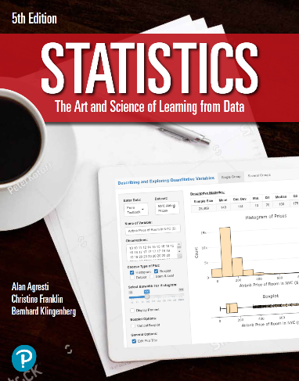

***“Statistics: The Art and Science of Learning from Data”***

**by Agresti, Franklin and Klingenberg, 5th edition**

**Chapter 3**

**Example 6: Internet and Facebook Use – Scatterplots**

## Reading in the data:

internet <- read.csv(file='https://raw.githubusercontent.com/artofstat/data/master/Chapter3/InternetUse.csv')  
colnames(internet) # To view the names of the variables in the dataset

## [1] "iso2c" "country"   
## [3] "year" "Population.Size"   
## [5] "GDP.in.billions.of..US" "GDP.per.Capita.in.thousands.of..US"  
## [7] "Internet.Users" "Internet.Penetration"   
## [9] "Facebook.Users" "Facebook.Penetration"   
## [11] "Broadband.Subscribers"

attach(internet) # so we can refer to variable names

## 

## Basic scatterplot

plot(x = Internet.Penetration, y = Facebook.Penetration, pch = 16, col = 'darkred',  
 main = 'Internet and Facebook Use for 32 Countries',  
 xlab = 'Internet Use (%)', ylab = 'Facebook Use (%)')

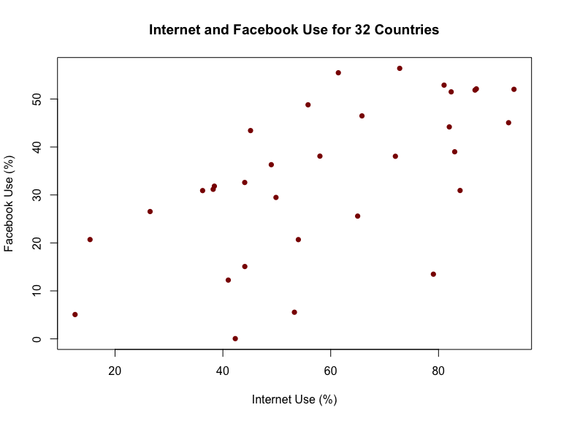

## 

## Creating scatterplot through ggplot2

library(ggplot2)  
ggplot(internet, aes(x = Internet.Penetration, y = Facebook.Penetration)) +   
 geom_point(aes(color = 'darkred'), show.legend = FALSE) +  
 labs(title='Internet and Facebook Use for 32 Countries',  
 x = 'Internet Use (%)', y= 'Facebook Use (%)') +  
 theme_classic() +  
 scale_y_continuous(limits = c(-5,65),   
 breaks = seq(0,60,10),   
 expand = c(0,0)) +  
 scale_x_continuous(limits = c(-5,105),   
 breaks = seq(0,100,10))

